Tourism Investment Opportunity
Student Center – Murchison Community Conservancy
Investment Prospectus
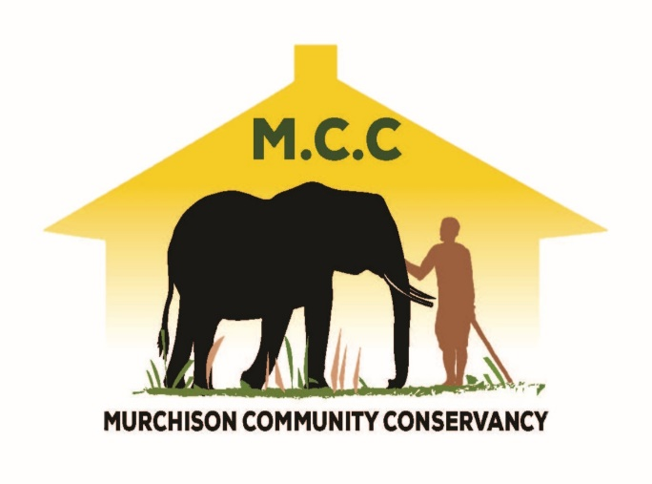

Prepared by USAID/Biodiversity for Resilience Activity
Contact: Juraj Ujházy, CFA, jujhazy@rti.org and Robert Senkungu, rsenkungu@awf.org

Opportunity
Murchison Community Conservancy (MCC) is seeking a private sector partner to manage and operate the existing Student Center (“Center” or “Facility”) north of Murchison Falls National Park in Nwoya District. The facility aims to serve growing Student visitation to the national park and the neighboring conservancy. The construction of the facility has been completed. Now the MCC is seeking experienced and entrepreneurial hospitality operator to enter into a concession agreement to operate the centre for business.

Market Background
Murchison Falls National Park is the largest protected area in Uganda, drawing significant number of both domestic and foreign visitors. The park visitation has doubled from around 50,000 visitors per year in the early 2010s to 100,000+ in 2019.
Despite the COVID related slowdown of 2020 and 2021, the park will remain the best savannah park destination in Uganda due to its size, accessibility, variety of habitats, attractions, and wildlife species. It hosts many rewarding and engaging activities for memorable safari.
The park has been popular with students, whereby schools from across the country regularly visit the park. 16,000+ students visited the park in 2019, up from 6,000+ per year in the early 2010s. These trips (by bus) usually require an overnight stay in the park at UWA Student Facility at Paraa.

Property Description
The Student Center is sitting on a three-acre piece of land. It has three structures – two for accommodation i.e., the male and female sections with rest rooms, and one structure with dining, store, and office space. The accommodation section has three spacious rooms each, totaling to six in all. The facility has a total estimated accommodation capacity of 76 persons. See the Annex 1 for photos.
Ownership
Currently, the property is owned by the African Wildlife Foundation, which has led its development in the past in partnership with the Murchison Community Conservancy. The plan is to transfer the legal ownership of the property to the MCC.
Location
The property is in Balyech Parish, Got Apwoyo Sub County, Nwoya District, GPS Coordinates: 36N 340818 283382

History & Past Investment
The Student Center has been developed by the African Wildlife Foundation since 2020, with support from USAID/Uganda. The Student Center was constructed to generate early revenue for the MCC. The land was bought by AWF and has a title deed and is secured with a chain-link fence. The property runs on solar lighting supplemented by a diesel-powered generator for heavy consumption equipment. All the three buildings are equipped with water tanks for storing and harvesting rainwater. The property is guarded with security personnel who are housed in the guard house.

Governance
The property is located within the Murchison Community Conservancy, which has been formed to govern and manage conservation and development activities within its boundaries (see the Map).
MCC is governed by an independent Board of Directors comprised of 15 members. The Executive Management of the MCC is planned to gradually commence its operations from 2022 and be responsible for functions such as conservation management and tourism/infrastructure development, and community relations.

Vision, Objectives, Products & Services
MCC Student Center Vision is to provide a place of excellent accommodation and related services to visiting students. The Center aspires to be a place of choice for the visiting students, with superb facilities supported by a portfolio of other quality services and activities, such as:
- Educational center
- Nutritious and healthy food
- Handicraft shop
- Outdoor activities (e.g., basketball, netball, volleyball), nature walks in the vicinity, library, and assortment of other games.
Additional commercial opportunities for the facility:
- Bicycling tours, bicycle rentals
- Provision of camping and budget accommodation to other domestic visitors
- Permaculture garden on site or in the neighboring community

Proposed Concession
MCC as the owner of the property seeks a long-term concession agreement with a qualified private sector partner to finalize completion, manage and operate the property.
Since the core of the property is complete, the concessionaire’s responsibilities will include:
- Finalize the completion of the property (e.g., furnishings)
- Develop additional product/services features (e.g., activities, playgrounds, educational center)
- Manage all aspects of operations of the property through its staff on the premises
- Conduct necessary repairs, maintenance, and upgrades
USAID/Biodiversity of Resilience is willing to consider a subsidy of $25,000 for this project (see the Investment Bid Process below).
The ideal partner will have these qualities and qualifications:
- Experience and success in the hospitality sector, especially in Northern Uganda
- Experience in developing and managing equitable partnerships with local communities
- Understanding of the tourism market (both domestic and international)
- Creativity to position and market the property as a unique and experiential product/service in the landscape, including for other institutions visiting Uganda
- Experience in the education sector and liaising/servicing schools
- Long-term commitment to conservation

Conservation and Development Aspects
The facility is located within the emerging community conservancy with its specific conservation and development objectives. The Center has been constructed with the aim to generate benefits for the conservancy and its members. Key principles:
- Innovation – applying best practices, developing new products/services, and using innovative partnerships.
- Green Operations – the facility should adopt strict eco-tourism approach governing the use of water, waste, and energy. Reduce/reuse/avoid approach to minimize impact. For example, the use of renewable materials and energy sources is required.
- Direct Linkage with Conservation Management – the enterprise should support financially some conservation management activities of the MCC, to address the threats (e.g., stop deforestation, reduce human wildlife conflict, land use planning guiding agricultural practices).
- Equitable Benefit Sharing and Community Skills – the business should include provisions to support improved community skills, local employment, and benefit-sharing (e.g., local supply chains, investment in local skills and capacities).

Investment Bid Process
The selection of the concessionaire will follow the three-step process:
- Submit Expression of Interest by September 30, 2022. See the template in the Annex 2.
- Pre-qualified partners will be contacted for further meetings and a site visit.
- Full proposals submission and evaluation for shortlisted applicants.

ANNEX 1. Photographs

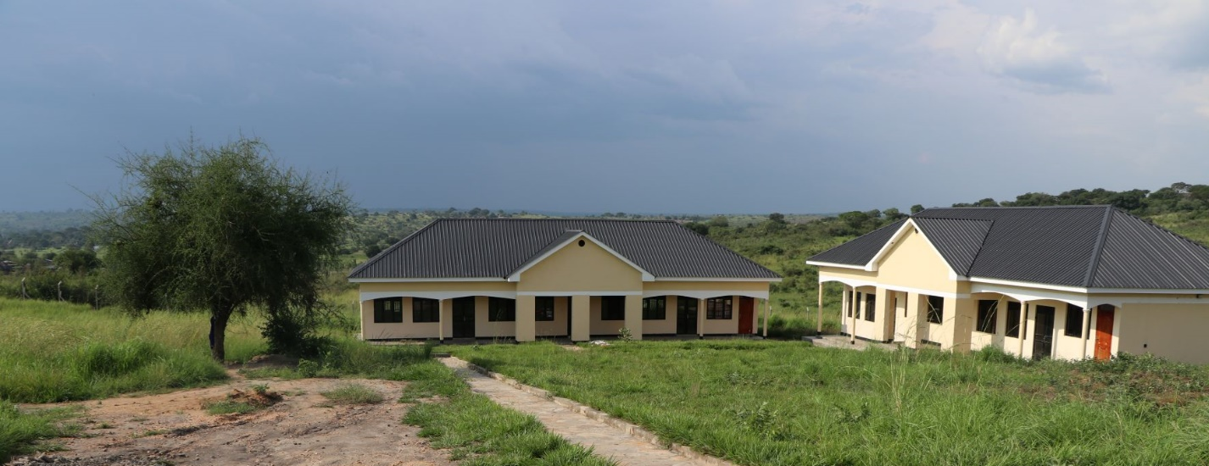
View of the property
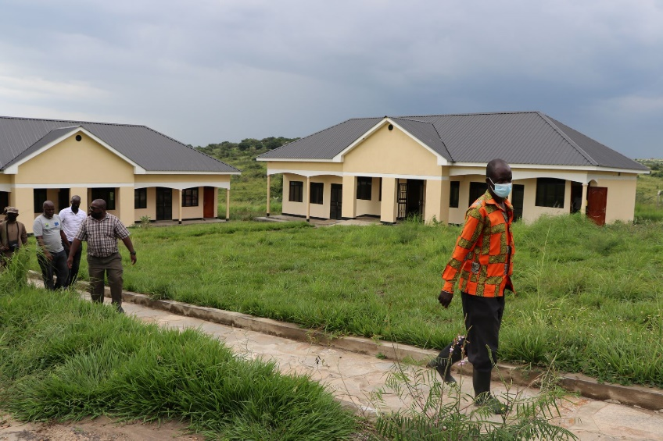
Visitors at the property
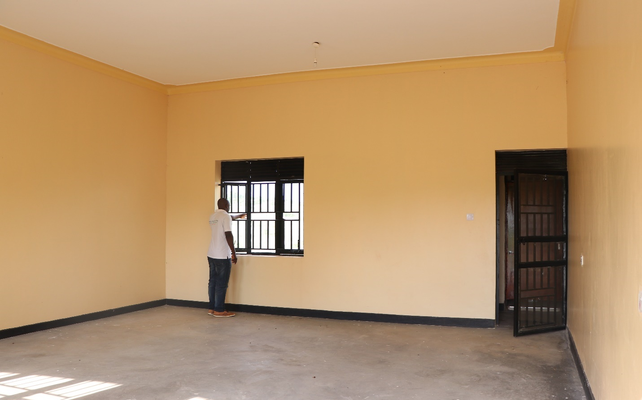
Interior Room

ANNEX 2. Expression of Interest Template

Instructions
Please submit the Enquiry Form following the exact template provided below.
___________________________________________________________________________________
Business Particulars
- Name and Contact
- Location (including the specific location of existing business operations)
- Ownership/Type of Entity
Business Profile/History/Relevant Experience – describe your existing business, its history and relevant experience in developing or managing similar properties (e.g., in hospitality sector). Provide some important milestones and successes you achieved. Describe your competitive advantage, why you would be best concessionaire for this project
Product / Service Description – explain your vision for the product/service to be offered by the Student Center, how these will be marketed and sold. Include how would you incorporate eco-friendly features into this facility.
Conservation Impact – describe how would you structure this enterprise to provide positive conservation impact on the Murchison Community Conservancy
Social Impact & Community Participation – highlight how would you plan to engage and positively support the neighboring communities.
Management Team – proposed staff team expected to manage the property, and any other key staff.
Financials & Investment Proposal
Your Existing Business
  - Annual Revenue (Historical and Projected Growth)
  - Audited or Internal Financial Statements for the past two years
Student Center Development
- Approximate Investment for the Project – approximate amount of investment needed
- Use of Funds (e.g., capital expenditures, marketing)
__________________________________________________________________________________
Maximum three (3) written pages will be reviewed and accepted.
The completed form should be submitted electronically to:
UGProcurement@awf.org

